L10-DBS301-savepoint rollback etc

Name: Abdul Rehman, Seneca ID : 149019176

You will **create 2 tables** first, then **remove / restore** these tables and also to **add / modify /remove** certain database objects like **views** in this lab.

1. Create table CITIES **from table LOCATIONS,** but only for location numbers less than 2000 (do NOT create this table from scratch).

🡪 You will have exactly 10 rows here.

When you describe CITIES, the output is shown below:

SQL> DESC cities

Name Null? Type

----------------------------------------- -------- -----------------

LOCATION_ID NUMBER(4)

STREET_ADDRESS VARCHAR2(40)

POSTAL_CODE VARCHAR2(12)

CITY NOT NULL VARCHAR2(30)

STATE_PROVINCE VARCHAR2(25)

COUNTRY_ID CHAR(2)

Statements:

create table cities as

select *

from locations

where location_id <2000;

Output:

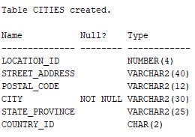

2. Create table TOWNS **from table LOCATIONS,** but only for location numbers less than 1500 (do NOT create this table from scratch). This table will have same structure as table CITIES.

🡪 You will have exactly 5 rows here.

Statement:

create table towns as

select *

from cities

where location_id < 1500;

Output:

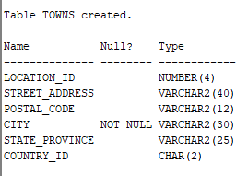

3. Now you will insert a row in TOWNS table, then delete the rows with Country_id CA. Check the new values with SELECT. Later run the command rollback, and then check the values in the table.

4. INSERT INTO cities VALUES (2000, ‘70 Pond Rd’, ‘M1L’, ‘Toronto’, ‘ON’, ‘CA’);

SAVEPOINT Insert_Done;

DELETE FROM cities WHERE country_id = ‘IT’;

SAVEPOINT Delete_Done;

UPDATE city SET city = 'York';

**Statements and Output:**



INSERT INTO cities VALUES (2000, '70 Pond Rd', 'M1L', 'Toronto', 'ON', 'CA');



SAVEPOINT Insert_Done;

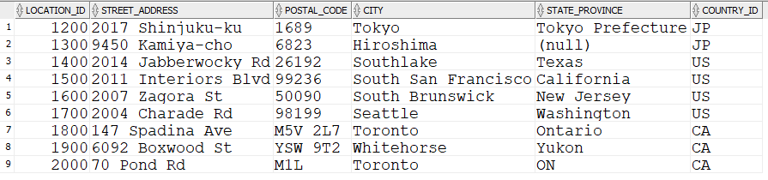

Rows: 9, country_id =’IT’ deleted.



SAVEPOINT Delete_Done;

What will be the result if you execute the following command:

* 1. ROLLBACK to SAVEPOINT Delete_Done;

Cities tables “city” column restored to original values.

* 1. COMMIT Delete_Done;

Says unknown command: commit deleted_done;

* 1. Rollback;

Says Rollback Complete but still shows the inserted cities row and the deleted row where country_id = ‘IT’

5. Add a check constraint in Cities table that will have country_id as IT and CA only.

alter table cities

add constraint counry_id_ck

check (country_id IN ('CA',’IT’));



6. Create simple view called CA_CITY_VU, based on table CITIES so that will contain only columns Street_Address, City and State_Province for locations only in CANADA. Then display all data from this view.

create view CA_CITY_VU as

select street_address, city, state_province

from cities

where country_id = 'CA';

select * from ca_city_vu;

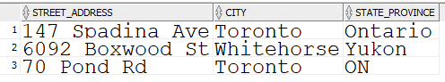

7. Modify your simple view so that will have following aliases instead of original column names: Street, City and Prov and also will include cities from ITALY as well. Then display all data from this view.

create or replace view CA_CITY_VU as

select street_address "Street", city "City", state_province "Prov"

from cities

where country_id IN('CA','IT');

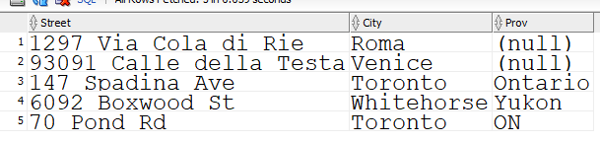

8. Create complex view called CITY_DEPNAME_VU, based on tables EMPLOYEES, LOCATIONS and DEPARTMENTS, so that will contain only columns Last_name, Department_Name, City and State_Province for locations in ITALY or CANADA. Then display all data from this view.

create view city_depname_vu as

select e.last_name, d.department_name, l.city, l.state_province

from employees e join departments d

ON e.department_id = d.department_id

join locations l

on d.location_id = l.location_id

where l.country_id IN('CA','IT');

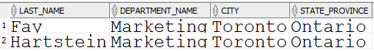

9. Modify your complex view so that will have following aliases instead of original column names: Lname, DName, City and Prov and also will include all cities outside United States.

Then display all data from this view.

create or replace view city_depname_vu as

select e.last_name "Lname", d.department_name "DName", l.city "City", l.state_province "Prov"

from employees e join departments d

ON e.department_id = d.department_id

join locations l

on d.location_id = l.location_id

where l.country_id != 'US';

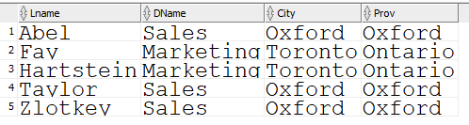

10. Check in the Data Dictionary what Views (their names and definitions) are created so far in your account. Then drop your CITY_DEPNAME_VU and check Data Dictionary again. What is different?

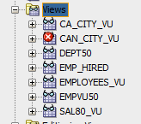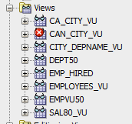Before: After:

City_depname_vu is no longer available.